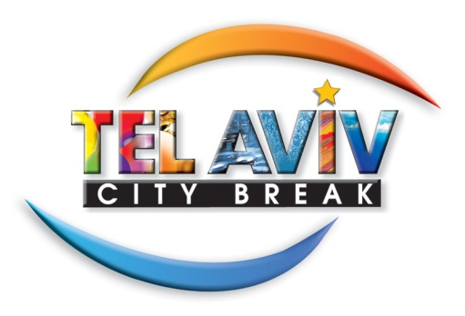
Список отелей участвующих в программе Tel-Aviv City Break

- Alexander Suites Hotel
- Art Plus
- Bell
- Best Western Regency Suites
- Carlton Tel Aviv
- Center Chic
- Cinema
- City
- Crowne Plaza Tel- Aviv
- Crowne Plaza City Center Tel- Aviv
- Diaghilev Hotel
- Dizengoff Suites
- Grand Beach Hotel
- Herods Tel Aviv
- Imperial
- Leonardo Basel
- Leonardo Boutique Tel- AVIV
- Marina Tel Aviv
- Melody
- Mercure
- Metroplitan
- Prima Tel Aviv
- Renaissance Tel Aviv
- Rothschild
- Savoy Hotel
- Shalom Hotel & Relax
- Tal
- Leonardo City Tower (Ramat-Gan)
- Leonardo Suite (Bat-Yam)

